**Midterm MSDS Experimental Statistics I Questions**

**Brian Kolovich**

Question 9:

**BONUS (3pts)**

Consider this test:

Ho: µ  =  8                                 alpha = .05

Ha:  µ  >  8                                assume σ = 10 and n = 16 and use a normal distribution.

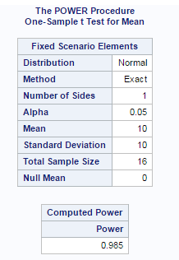

We get a predictive power of 0.985, which is very high!

**SAS Code**

proc power;

onesamplemeans

alpha = 0.05

sides = 1

mean = 10

stddev = 10

power = .

ntotal = 16;

run;